# Taking a Bite out of Apple

An overwhelming number of people (economists and normal) agree that government intervention and regulation of the market is necessary. The key question is just how much. A new situation with Apple Inc. may help frame a small corner of that debate.

As reported in the *Business Insider* article entitled [*Dropping Imagination Technologies gives us a rare look at how ruthless Apple can be*](http://www.businessinsider.com/analysts-dont-know-whether-imagination-technologies-will-survive-the-fallout-with-apple-2017-4), Sam Shead details a recent tiff between the giant California computer company and Imagination Technologies, a UK-based chip manufacturer.

According to the article, Apple was in a partnership with Imagination Technologies (IT) for the last 10 years for purchase of the latter’s GPU-based chip set and accompanying technology. These purchases amounted to just over half of IT’s £120 million revenue and made it into something of a UK darling in the technology arena. Their GPUs power Apple’s family of mobile devices including the iPad and iPhone and it partnership seemed like a marriage made in heaven.

Well the divorce proceedings are underway and it started, as in most cases, with covetousness. Apple really wants to own IT’s GPU technology. It tried to purchase the company, has poached some of its key executives, and finally issued a public message that they will be dropping IT in the near future. The net effect was to tank IT’s stock by 65% and put the solvency of the 1700-person company in serious doubt.

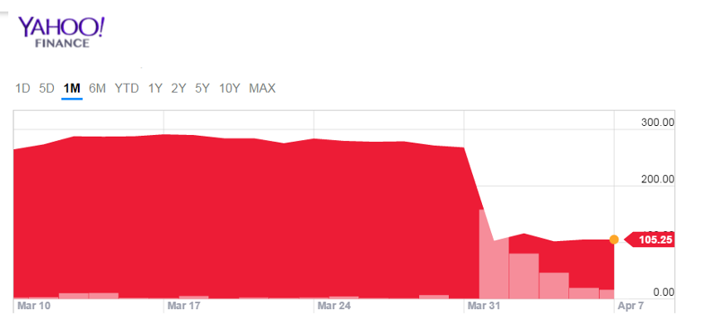

Two questions are why does Apple want to own the GPU technology and why issue a public statement announcing the dissolution of the partnership well in advance?

To answer the first question, the article cites Benedict Evans, who makes the case that Apple, which already owns an industry-leading design for System on a chip (SoC – chips that control other chips), is now looking to acquire and control GPU-based technology. Evans believes this will give Apple a competitive advantage in computational photography (a heading under which all the panoramic and motion features Apple advertises falls) and in machine learning. That seems all well and good. Apple believes that controlling the hardware it uses helps it control its own future.

But the answer to the second question is a bit more disturbing. After failing to buy IT, Shead suggests that Apple’s strategy behind the public issuance of the divorce proceedings was to make IT vulnerable to outside purchase. With its stock depressed, Imagination Technologies can now be acquired for far less of a capital outlay than before. Apple has positioned itself to purchase IT on the cheap and to have its own management, which it lured away from IT, ready to step in and run it. In his piece, Shead aptly points out that this move by Apple sends

<[t]he message that other companies are likely to hear — whether Apple intends it or not — … "cooperate or die.>

If you are uncomfortable with what seems unfair business practices then you are arrived at precisely the point where we can talk about government intervention and regulation of the market. What role does the government have in this situation? Are Apple’s practices part of a predatory stock manipulation or shrewd business sense?

Before answering, consider that Apple is not the chrome-plated squeaky clean company either it or its adherents like to pretend. It has had a long history of putting out operating systems for iPad and iPhone that are devoid of the amenities its customer base take for granted on the Mac computers. Apple sits back and watches the app development ecosystem and then swoops in for the next release with a built-in feature that mimics a popular app, thereby advancing its own intellectual property at the expense of the independent developer who had the idea in the first place. This practice, sometimes call freesearch and development, should raise some eyebrows about the ethical standing of the ‘Cohort of Cupertino’.

Clearly the EU is already taking aim. As Shead puts it

< But acquiring Imagination after sinking the company's stock would attract criticism and a lot of bad PR for Apple, which would be especially unwelcome now that the European Union is scrutinising the company's every move in Europe.>

What Shead is referring to is the ongoing battle between Apple and Ireland, on one side, and the EU on the other. The latter claims that Ireland offered Apple illegal state aid by setting the technology giant’s effective tax rate at 0.005% in 2014. The former are claiming that the EU is “failing to act impartially”. However, this particular dispute ends, it is clear that Apple is already in the government crosshairs across the pond.

But should it be?

What, if anything, is wrong with the above practices? Apple is a big company. It represents the intellectual capital and inventiveness of tens of thousands of intelligent and skilled people. It’s market capital reflects the confidences of millions of investors. And its products are bought by hundreds of millions of customers each year. It is hard to argue, from this perspective, that society isn’t being served well.

Nonetheless there seems to be a sleazy nature about Apple’s business practices. They swing their collective might around to get sweetheart tax deals. They encourage development for their app ecosystem and then stamp out innovative teams by co-opting their intellectual property. And now they are poised to do it on a large scale with Imagination Technologies, where, by their own actions, they may have spelled the end for a 1700-person tech company. What’s more, is that it is uncertain, as IT points out, that Apple can develop its own GPU substitutes without deeply infringing on IT’s intellectual property. So, from this perspective, it’s hard to argue that Apple should be allowed to bully its way around the market simply due to its size.

Where does the balance live?

Well, I think it doesn’t live in the government intervening, at least not directly. Certainly, laws should protect Imagination Technologies’ intellectual property and the full weight of the court should be brought to bear if Apple infringes it in any way. But should the government try to make nice between the companies? I don’t think so. Imagination Technologies knew what it was getting into bed with or it should have. Whether they go out of business or manage to survive their divorce with Apple, the clarion call has already been sounded to all other businesses who think about partnering with Apple: be careful of doing business with them. Some of these businesses would then seek deals with Google or Microsoft, neither of which are any more innocent and pure than Apple. But these niche tech companies can play one giant against the other. The market can correct itself if given a chance.

Government intervention would result in a quick fix but with two long term negative side-effects. First it would stave off the needed competition between the tech giants. Second, it would send the message “go ahead and screw up, the government will fix it” to all the smaller firms that they don’t need to be careful when they partner with the big boys.

Of course, there is another sector of this story that would ordinarily also contribute to market self-correction: the consumer. Ordinarily, the PR associated with the tactics Apple employs would leave a foul taste in the mouths of customers and sales would drop. The message would be sent by the most critical component of the market that these practices are not to be tolerated. Unfortunately, I don’t think the Apple customer base is that enlightened. As the Onion so aptly satire in their piece on the [Macbook Wheel](https://www.youtube.com/watch?v=9BnLbv6QYcA&t=106s), the Apple customer may be a bit blind.:

<my snippet here>